**PPI UK & PPI GREATER LEEDS**

**ISIC X SCI ESSAY COMPETITION 2021**

**Essay Title :**

**INNOVATION ENGINEERING OF FUTURE FLOATING CITY AS A SOLUTION TO THE PROBLEM OF POPULATION DENSITY IN MEDAN CITY**

“Indonesia Levelling Up! Breaking Through Covid-19 Multi-Dimensional Crisis”

**Subtema:** Built Environment & Infrastructure



**Proposed By:**

**DHEA ALVIOLITA WARMAN**

**UNIVERSITY OF SUMATERA UTARA**

**MEDAN, INDONESIA**

**2021**

**INNOVATION ENGINEERING OF FUTURE FLOATING CITY AS A SOLUTION TO THE PROBLEM OF POPULATION DENSITY IN MEDAN CITY**

Dhea Alviolita Warman

University of Sumatera Utara

dheaalviolita@gmail.com

**INTRODUCTION**

Medan is the third largest city in Indonesia after Jakarta and Surabaya, with a population of 2 million in the metropolis. Based on data from the Department of Population and Civil Registration in 2019, the total population of Medan was 2,279,894 people with a relatively high average population growth rate of 2.97%. One of the major reasons is its geographical position as a coastal settlement making Medan a potential stopover and settlement for migrants. The immigration process is what causes the population growth rate of Medan City to increase from year to year. It has increased the demand for residential land for residents. In addition, the dense residential areas, the need for land for housing, commercial needs, and recreation mean that there is no longer any vacant land that can be used for sanitary landfill.

Meanwhile, climate change that occurs slowly over a long period of time between 50-100 years is estimated to increase sea water as high as 19-95 cm by 2100 which will result in the loss of islands or land in the world, for example. loss of land in Egypt 1%, the Netherlands 6%, Bangladesh 17.5% and 80% in the Marshall Islands and the sinking of the islands of Fiji, Samoa, Vanuatu, Japan, the Philippines and Indonesia. In addition, the results of observations at several research station locations indicated that there was an increase in sea level in Medan by 7.83 mm. According to the Ministry of Marine Affairs and Fisheries (2019), coastal areas such as Medan City and small islands will sink 100 years from now and will lose an average of 4.76 hectares of land or islands per year. The following is a projected image of sea-level rise for 100 years according to the European Environment Agency (EEA):

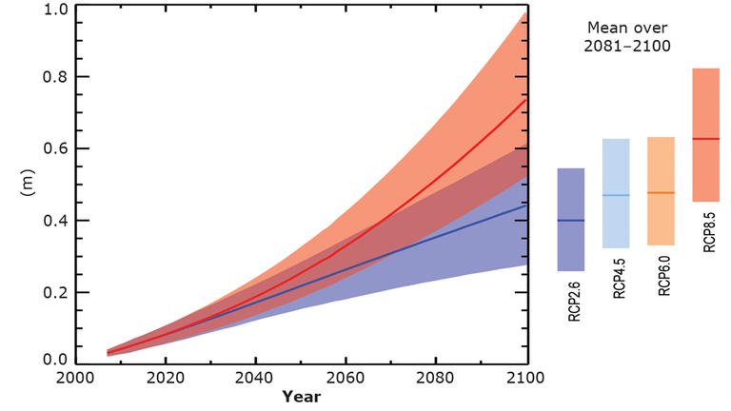

**Fig 1.** Projection of the Lowest, Middle and Highest Sea Level Rise in a 100-Year Period

The Medan city government has yet to issue a concrete policy to overcome this problem. The policy taken is only in the form of beach reclamation. Coastal reclamation has not become the right solution to increase the area of residential land because it causes many losses, one of which is damage to the marine ecosystem. In addition, fishermen around the coast will lose their sources of life.

Medan Floating Shape Tube is a future floating city concept that has several advantages such as, solving the problem of floods and energy crisis, allows for flexible city planning, has international appeal, does not require a supply of sand to prepare land for building time thus saving and money, no incurring repair costs as settlements on land. Floating city consists of block components of several floating houses that are united in a town ring. A tower rises from sea level, becoming the center point of this floating house design. This tower has the main function of maintaining the position and as a place for the city's fluctuating motion when tides occur.

With the design of the Medan Floating Shape Tube idea, it can make an alternative as a solution to the high rate of reduction of land settlement due to population and sea-level rise and replace reclamation techniques that contribute to the destruction of the underwater ecosystem.

**CONTENTS**

1. **Solutions Ever Offered**

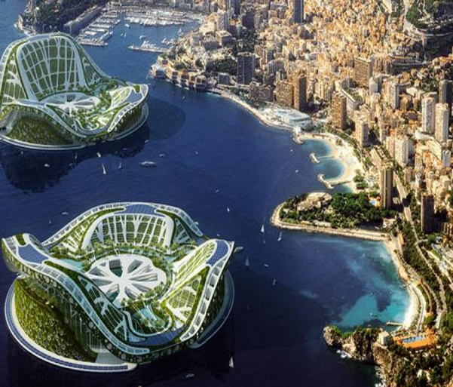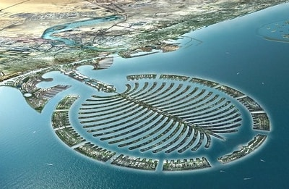The first issue concerns the need for the residential land area as the population grows. So far, the existing solutions to increase the area of ​​residential land, one of which is the coastal reclamation road. Reclamation is a job or an effort to use an area of land that is relatively useless or is still empty and watery to become useful land by drying it. For example, in coastal areas, swamps, offshore or in the sea, in the middle of a wide river, or a lake. As is well known, the reclamation of the Pantura coast of Jakarta has had many negative impacts on the environment. Biodiversity that is estimated to be extinct due to the project includes the loss of various mangrove species in Muara Angke, the extinction of thousands of fish, shellfish, crab, birds, and various other biodiversities, changing the landscape (geomorphology) and water flow (hydrology) in the area. North Jakarta. Coastal reclamation has not become the right solution to increase the area of ​​residential land because it causes many losses, one of which is damage to the marine ecosystem. In addition, fishermen around the coast will lose their sources of life. The second issue concerns sea-level rise. The solution that has been offered with this problem is to create an artificial floating city, we take the example of Lilypad floating city. This floating city can be moved towards the coast or moved freely to follow the ocean currents. This city has the concept of an ark hotel which is interpreted to be able to protect humans from climate change.

.

**Fig 3.** Future Residential Concept Based on Beach Reclamation and Lilypad Floating City

In our opinion, the artificial floating city with this concept is quite dangerous, because this floating island with the Lilypad Floating City concept will be carried away by the ocean currents and its direction is uncertain because it does not stand in one area permanently. The following are the weakness parameters of some of the solutions that have been offered :

**Table 1.** The Weakness Parameter Of The Idea That Has Been Offered

|  |  |  |
| --- | --- | --- |
| Parameters | Beach Reclamation | Lilypad Floating City |
| Function | Increase the land area of the coastal area for settlement | A floating city as a residential land solution |
| Advantages | Easy to apply today | * Stable shape * Independent in energy sources * Based on "green design" |
| Ecological Impact | Very big on the coastal ecosystem | Nothing |
| Resistance to Ocean Currents | Prone to sea water abrasion | Being carried away by the current is not necessarily the direction because it does not stand in one place |

1. **New Ideas To Be Offered**

Medan Floating Shape Tube is an interesting floating city project concept and the first in Indonesia, especially North Sumatra. Several similar design concepts have actually been produced, such as the Urgenda Floating City, Ijmeer, and Zuidplaspolder. According to Rojman (2008), this design concept was chosen because it has several advantages, including:

* Resolving the flood and energy crisis problems
* Allows for flexible city planning;
* Has international appeal
* Does not require a supply of sand to prepare land for building time, thus saving and money;
* Does not incur repair costs as in settlements on land

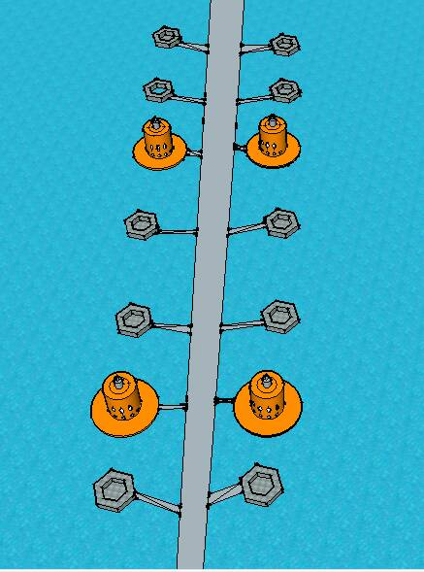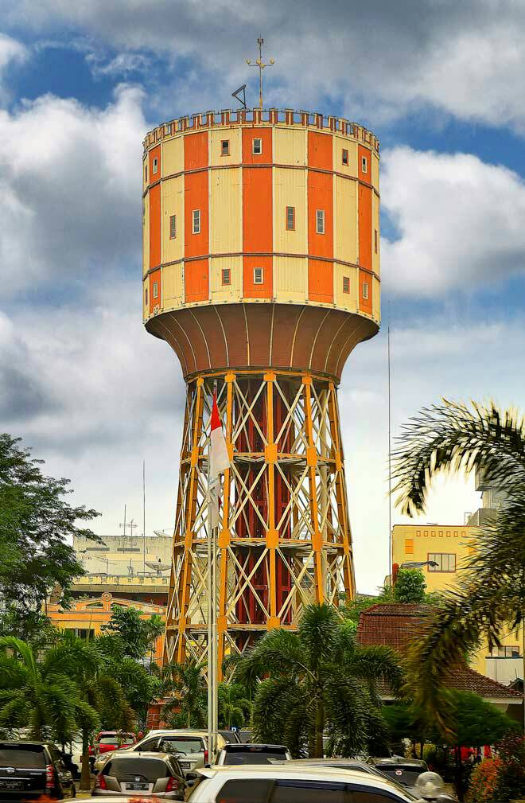The following is the urban distribution pattern :

**Fig 3.** City Component Design Pattern (a) Tirtanadi Tower (b) Floating City Design Pattern

The urban design pattern is inspired by the Tirtanadi tower which is indeed an icon of the city of Medan. This form will function as the main component of the city in the form of a building. The structure was made by reclamation and was the only component of the city that didn't float.

Medan Floating Shape Tube consists of block components from several floating houses which are joined together in a town ring. A tower rises from sea level, becoming the center point of this floating house design. This tower has the main function of maintaining the position and as a place for the city's fluctuating motion when tides occur. A fluctuating motion system is needed to obtain a complete floating concept, namely the position of the town ring will remain afloat even though the sea-level changes, in anticipation of the water level at its highest level. Globally, this structure is divided into 4 parts, namely the top rise (used as a signal catcher, lightning rod), the fluctuating area of the town ring, the support body, and the foundation. The top-rise structure is made of high-strength steel frames which together, these frames will be able to bear the combined loads of factors like skyscrapers on land.

**TOP RISE** : High-strength steel construction to maintain the position of the city's fluctuating motion when tides occur,

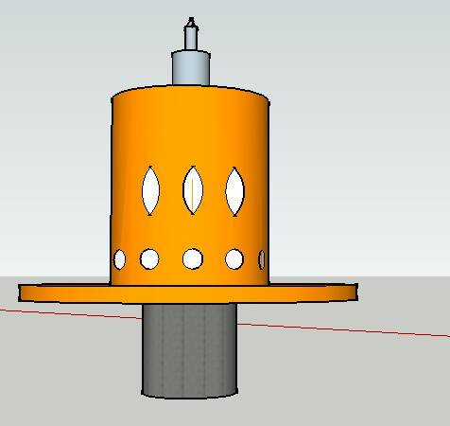

**FLUCTUATIVE AREA :** Made of steel covered with concrete to withstand the stressful loads of the town ring due to waves (such as berthing loads on a pier)

**TOWN RING :** In the form of a ring bowl that functions as impermeable walls that hold water from the outside and receive the upward pressure of water so that this structure can float.

**FLOOR BODY**: The structure is the same as the fluctuating area

**FOUNDATION:** final load bearer

**Fig 4.** Floating Shape Tube Terrain Cut Design

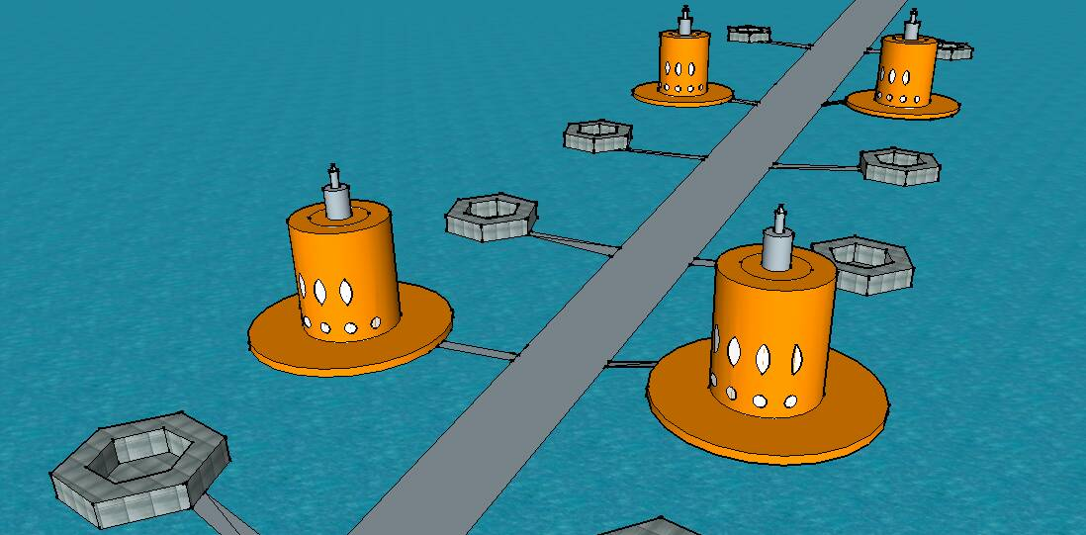

**Fig 5.** Floating Shape Tube Field Perspective Design

The structure for the town ring's fluctuating area is made of steel with concrete casing on the four outer main legs to withstand the pressure loads of the town ring due to waves (such as berthing loads on a pier). This meeting uses a system like the one where the monorail meets its rails, so it is hoped that by using this system, fluctuating 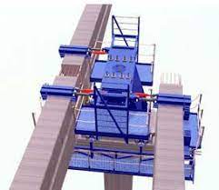movements will be smoother and more dynamic.

**Fig 6.** The City's Fluctuating System Using the Monorail Technology

The structure of the support body consists of several support poles made of steel. This structure is more like the construction of an offshore building where in addition to being able to support the loads on it, it must also be stable to the environment and load loads in the waters such as wind loads, waves, tides, currents, active geological processes in the form of earthquakes, faults, seabed instability, scouring, and shallow gases, marine vegetation, other environmental data such as sedimentation, fog, air and sea water temperature. Like most other offshore building structures, the lowest structure uses a pile foundation structure. It is the bonding force between the pile and the seabed that has the most influence on its strength in supporting the load. The outer leg of the pile needs to be tilted outward to increase the space on the ground so that it increases resistance to rolling.

1. **Supporting Data for City Structures and Systems**

The town ring structure is in the form of a ring bowl that functions as impermeable walls that hold water from outside and receive the upward pressure of the water so that this structure can float. Other structural elements such as the framework (web frame) directly assist these functions and some only act as a support or support so that these main elements always remain in their position so that they can function effectively. The main material for this structure is partly steel, and for certain places glass, aluminum and copper are used as fill materials.

Because the structure of this city resembles a ship, in its planning, it must also be seen as the structure of a ship. Therefore, this structure must be able to withstand loads such as: (1) bending loads due to the shape of the structure, (2) the effect of water pressure, (3) panting stresses, namely stresses due to pitching, (4) pounding, (5) load due to local mass, and (6) vibration due to operation of pumps and other machinery that may be required. In this town ring, there is a road as the main access that allows transportation modes from outside to enter and leave. To support the earth-saving program, private vehicles are prohibited from operating in the city, instead, there are modern trams as a means of transportation in the city for the mobilization of residents. The path follows the distribution pattern of the city components where each block has the following points:

* **Supply Energy**

This floating city tries to use local resources as much as possible for the fulfillment of electricity and clean water. Given that the energy efficiency, especially the electricity generated, is still relatively small (around 20-50%), a combination of several power plants will be very helpful. The combination referred to includes the use of solar cells and Bayu power plant. While the structure is designed to use heat-reducing glass so that there is an efficient use of sunlight and solar heat. However, during project work, energy supply from outside is still needed.

* **Sanitation System**

The drainage and wastewater treatment systems apply a ballast water system to the ship by pumping it out. A pipe is installed in the ring bowl that connects one house to another. These pipes will flow to the bottom of the bowl. Before being released into the sea, this waste water will be collected first to be purified so that when it is released, this waste water does not disturb the marine environment.

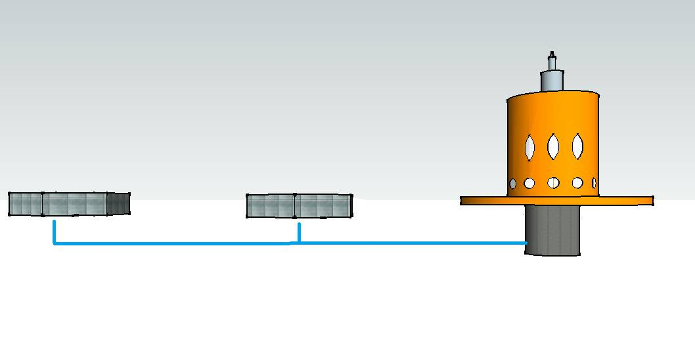

**Fig 7.** Drainage System (Dirty Water - Pipe - Storage - Purified - Discharged into the Sea)

* **Development and Sustainability**

The floating city project will indeed require huge resources, both in terms of financial and technical implementation. However, optimism arises considering the development of technology and human creativity which is getting more extraordinary from time to time. Several mega projects such as the Burj tower project, the artificial island in Dubai which several decades ago were still considered impossible, have been able to be created by humans very well. For now, the development of civil construction technology, engineering, shipping and computer science has grown rapidly. Some of the technologies that support the development of a larger city include:

1. The development of several finite element-based structural analysis tools such as Ansys, Adina, which in addition to providing analysis speed and high accuracy of results, also allows users to analyze structures in various shapes, even for irregular shapes.
2. With the emergence of an ULCC (ultra-large crude container) type container ship with the ability to carry a cargo of 550,000 dwt or about 1.5 million tons, city components such as housing, transportation facilities that have a large mass are no longer a problem.
3. The emergence of giant cruise ships such as queen marry, in which the structure in it is more like a city so that it can be used as a reference for the concept of a floating city.
4. The development of structural science, such as the discovery of UHSC concrete which has a reaching compressive strength, can be used as a support structure in the substructural structure, which theoretically receives the largest compressive force flow.

**CONCLUSION**

1. **Prediction of Transfer of Ideas**

The Medan housing project plan, especially converting water to land (reclamation), has an impact on reducing the main water storage capacity as well as reducing wetland areas. The floating city concept is designed to reduce this capacity and create housing in anticipation of projected climate change, especially due to sea-level rise. By applying the concept of land expansion based on this non-destructive model, efforts to protect marine life and its ecosystem will be realized and maximized. The use of Medan as an application area is in accordance with the RT/RW of the Medan city, where the coastal part of Medan will indeed be used as a developed tourist and business area. This concept is very suitable for this purpose because of the unity with the conditions of the components of the city and waters there. Good cooperation between stakeholders and field subjects is needed to achieve project success.

1. **Strategic Steps for Implementing Ideas**

Strategic steps need to be planned carefully so that this floating city can be realized properly, acceptable and sustainably. There are 4 transition management needed in this phase, including:

* Stage 1: Building a transitional space and building a vision

At the initial stage, a large meeting is needed that involves people consisting of representatives of government, companies, and institutes/universities to come together, discuss concepts and unify the views and goals of this floating city project.

* Stage 2: Develop cooperation and a transitional agenda,

Due to the complexity of the problems that will be faced in creating a floating city, it is necessary to have good cooperation between the parties who are able to solve them. The cooperation in question can be in the form of consultation, cooperation in project work or the delivery of information.

* Stage 3: Mobilize the parties involved and implement the transition project,
* Stage 4: Evaluation, monitoring and learning.

The difficulties and experiences that exist in creating this floating city can be used as lessons for improvement and model development.

**REFERENCE**

Adryati. 2007. Penerapan Standar Bidang Bahan Bangunan dalam Pembangunan Infrastruktur Perumahan dan Permukiman, Journal Standardisasi. 9(3): 77 – 86.

Akkermans, Carien. 2008. The Floating city. http://ocw.tudelft.nl/fileadmin/ocw/courses/TechnologyinSustainableInnovation/res00032/!54686520466c6f6174696e672043697479.pdf Diakses pada tanggal 19 Mei 2021.

Akmal. 2013. Eksplorasi Desain Rumah Hijau (50 Karya Pilihan Propan Green Building Design Competition). Architectural Writer Studio, Jakarta.

Altman, I and Carol Werner, 1985, Home Environment, Plenum Press, New York.

BPS. http://sumut.bps.go.id/ accessed on May, 19th 2021

Budiarso, UR. Wisnu, ST, MT. 2014. Kajian Disain dengan Metoda Post Occupancy Evaluation Rumah Susun Sarijadi Bandung, Fakultas Teknik Universitas Budi Luhur.

Graaf, Rutger De.2008. Floating city Ijmeer - Accelerator for Delta Technology. Ijmeer. DeltaSync04

Jan Rotman.2008. The Floating city Into an Ocean of Opportunities. http://www.urgenda.nl/documents/Prospectus%20Floating%20EcoCity%20ENG.pdf accessed on May, 19th 2021

Kurdi, Siti Z. 2011. Identifiksasi Kerugian Kawasan Pantai Akibat Kenaikan Muka Air Laut. Puslitbang Permukiman

Kusna, Indra D jaya. 2011. Teknik Konstruksi kapal baja. Direktorat pembinaan Sekolah Menengah Kejuruan

Pemko Medan. 2014. Penyusunan Rencana Detail Tata Ruang (RDTR) Kecamatan Medan Maimun. Dinas Tata Ruang dan Tata Bangunan, Medan.

Rencana Pembangunan Jangka Menengah Daerah Kota Medan 2011-2015

Wölfel, Roland von et all. 2012. The Guideway System of the Monorail Kuala Lumpur Design & Erection. <http://www.lap-consult.com/pdf> files/deutsch/sonderdrucke/sdr481.pdf accessed on May, 19th 2021